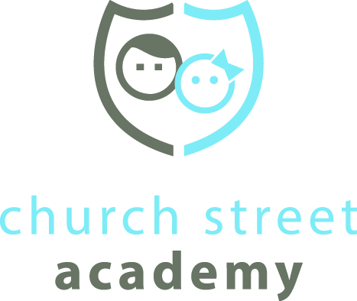

I, _________________________, have watched the parent orientation video and read the parent handbook. I agree to abide by all the policies set forth by Church Street Academy in the video and in the parent handbook.

Parent signature Date

